Air Name ___________________________________________ Date ________________ Period_______

Study Guide – Fronts and Systems
A. Matching – match each of the following definitions to the correct term
- Front
- Cold Front
- Warm Front
- Stationary Front
- Thunderstorm
- Hurricane
- Tornado
- High pressure
- Low pressure
- Maritime
- Polar
- Continental
- Tropical
- Air Mass
- ____J____ Air mass that forms over water – moist air
- ____M____ Air mass that forms close to the equator – warm air
- ____D____ Warm and cold air mass meet with the same force
- ____N____ Large body of air with the same temperature and humidity
- ____L____ Air mass that forms over land – dry air
- ____B____ Cold air mass runs into a warm air mass forcing the warm air up
- ____C____ Warm air mass runs into a cold air mass and slides over the top
- ____K____ Air mass that forms far from the equator – cold air
- ____A____ Boundary between air masses
- ____H____ System that usually brings clear skies and calm weather
- ____I____ System that usually brings stormy weather and high winds
- ____E____ Takes place in a cumulonimbus cloud, includes thunder, lightning, wind, and rain
- ____F_____ Spiral arrangement of thunderstorms that form over warm ocean waters
- ____G_____ Violently rotating column of air between a cumulonimbus cloud and the ground
B. Fill in the blank
- A(n) ______Cold Fronts__________________ front creates heavy rain and thunderstorms.
- A(n) ______Warm Fronts____________________ front creates light rain and thin clouds.
- A(n) _______High Pressure System_____________________ brings clear skies and calm weather.
- A(n) ______Low Pressure System____________________ brings stormy weather and strong winds.

C. Short Answer: Using the map given, answer the following questions.
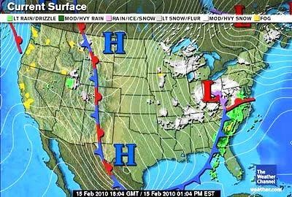
- What type of front is moving into Florida? How should the weather change?
Cold Front, The weather will change to thunderstorms and heavy rain

- What kind of weather system is over Texas? What type of weather should they expect?
High Pressure System, Weather will be clear sky and sunny.

- What kind of weather system is causing the cloud cover and storms on the east coast?
Low Pressure System

D. Short Answer: Answer each of the following questions completely.

- Name the four major types of weather fronts and draw the symbol for each.
Warm Fronts
Cold Fronts
Stationary Fronts
Occluded Fronts

- The weather in Phoenix cooled down this week and there were large thunderstorms with cumulonimbus clouds. What kind of weather system and what kind of front caused this change?
A low pressure system carrying a cold front caused this change in weather.

